Name:______________________
Block:______________________

Regional Geography Unit Test 2014
Rules: You have 70 minutes to complete the test in any order you wish.
No talking. No cell phones.
Test answers must be written in pen. (Any answers not written in pen will not be eligible for a remarking.)
Part 1 consists of 15 multiple choice questions and you must choose the best answer. There is only ONE answer for each question.
Part 2 consists of 10 atlas skills questions. You do NOT need an atlas for this section. All information needed is provided in this test.
Part 3: consists of 5 short answer questions. Write no more than 2 sentences to answer each question.
Part 4: is an essay question. Choose either Option A or Option B. You only have to answer ONE.

Part 1: MC____/15
Part 2: Atlas Skills ____/10
Part 3: Short Answer ___/15
Part 4: Essay ____/10
Total Marks: ____/50

Part A: Multiple Choice. Choose the best answer for the following questions. There is only one correct answer for each question.
- Rock that is changed from its original form through heat and pressure is:

a. sedimentary
b. metamorphic
c. igneous
d. altered

- The Appalachian Region was once:

a. the floor of an ancient sea
b. covered with molten magma
c. an ancient, now eroded mountain range
d. a flat plain with many large rivers

- The Innuitian Mountains are similar to the:

a. Appalachians
b. Coast Range
c. Rockies
d. Canadian Shield

- The Interior Plains were once:

a. covered with water
b. covered with volcanoes
c. a harsh desert
d. heavily forested

- Which of the following is NOT true of the Canadian Shield:

a. its topography was altered by the actions of glaciers
b. its geological formations are ancient
c. metamorphic rock forms much of the Shield
d. its climate is suitable for farming

- Vancouver is in a region that has:

a. deserts and cacti
b. a raised plateau that prevents the city from flooding
c. orographic precipitation
d. mostly sinkholes

- A marsh:

a. is so acidic that nothing grows in its environment
b. a type of wetland
c. is NOT in risk of future human developments to the land.
d. cannot be created when beavers are in the area.

- Climate change is NOT:

a. global warming
b. a raised plateau that prevents the city from flooding
c. orographic precipitation
d. mostly sinkholes

- The first people who arrived in North America came by:

a. An intergalactical space landing from planet 55 Cancri e
b. Oriental ships from China and Japan
c. A bridge that connected Siberia with Alaska
d. Viking ships that landed in Greenland before finding Newfoundland

- Fold mountains are NOT associated with:

a. lava cooling that adds rock material to mountains
b. the tectonic forces that causes the mountains to uplift
c. the Appalachian Mountains
d. the Innuitian Mountains

- What does a map have:

a. Scale
b. North Arrow
c. Legend
d. All of the above

- Coniferous trees:

a. shed their leaves in the winter
b. are found in the Canadian Shield
c. do not have cones
d. all of the above

The last three multiple choice questions refer to the climograph shown below:
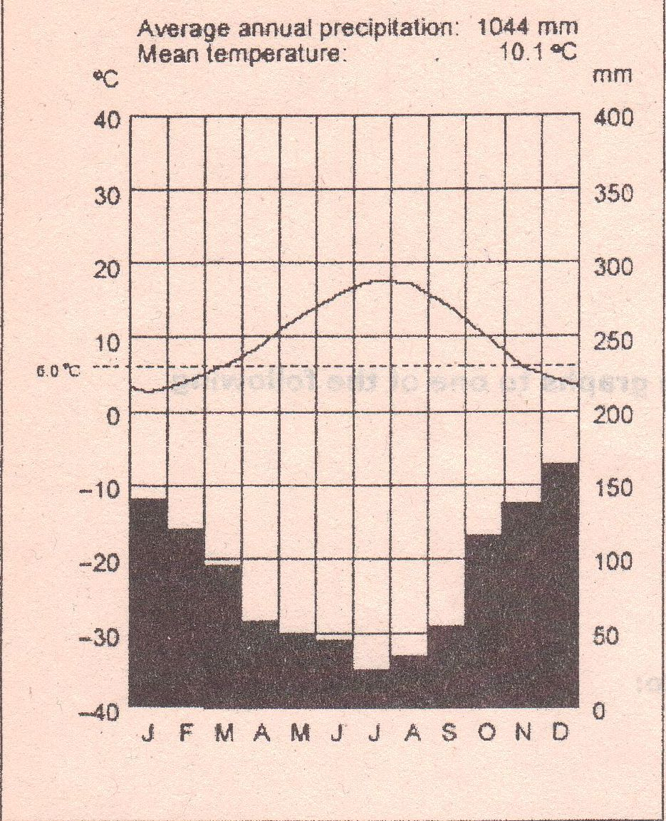

- The highest temperature recorded for the year is:

a. 18 degrees Celsius
b. -9 degrees Celsius
c. 160 degrees Fahrenheit
d. 2 degrees Celsius

- The climate of this region tends to have:

a. mild temperatures
b. less rainfall in the winter
c. hurricanes
d. all of the above

- The lowest rainfall recorded in the year happened in what month?:

a. April
b. May
c. June
d. July

Part C: Short Answer
- What is the difference between climate and weather? (2)
Climate= AVERAGE temperature and precipitation measurements over a year
Weather= daily forecasts of temperature and precipitation projected to 1-2weeks

- How did glaciers contribute to the St. Lawrence Lowlands region? (3)
Glacier deposits material. Glacial meltwater turns area into lake. Lake shrinks and leaves behind fertile soil.
- What is permafrost and how does it influence the vegetation type around the region? (3) Permafrost= frozen soil. Frozen soil does not allow much to grow in it. Vegetation types that can= low shrubs, mosses, and lichens.

- Draw a diagram of orographic precipitation. Label the steps that are involved with this process. (6 marks)

See diagram posted on website.

Part D: Paragraph question.

*Note: Do not expect this type of question on the test. Expect the type of question I actually asked you on the sample test.” When you see a really general question like the one I asked you on your version this is what you should think about: (Analyze the following map of North America. To the west and the east are some indicated mountain ranges. How were these mountains formed? What are some similarities and differences in the formation of these mountains? How did they affect people arriving to this continent?)* (10)
- Mountains to the east are Appalachian mountains and are formed by the folding up of 2 continental plates. (2marks)
- Mountains to the far west are volcanic coastal mountains and are formed by subduction that forces magma up creating these volcanoes. (2marks)
- The second set of mountains to the west are the Rockies. These mountains are fold mountains just the same as the Appalachians. (2marks)
Similarities: They’re both on the edge of the water—the region between the mountain and the water will experience OROGRAPHIC PRECIPITATION. (2marks)
Differences: (shown above when you explained the 2 different mountain types)
People coming from European ships will hit Atlantic coast and will have a very difficult time passing through these mountain ranges if it is even possible for them at that time. (2marks)

So Basically: If I ask you a similar question—tell me how it affects humans (2marks), what are the physical landforms you see, how do these landforms form, and tell me something about the topography, climate, and vegetation that’s there.

