Name:______________________
Block:______________________

Canadian Geography Unit Test 2014
Rules: You have 75 minutes to complete the test in any order you wish.
No talking. No cell phones.
Test answers must be written in pen. (Any answers not written in pen will not be eligible for a remarking.)
Part 1 consists of 28 multiple choice questions and you must choose the best answer. There is only ONE answer for each question.
Part 2 consists of 10 atlas skills questions. There will be a map provided in your test booklet. Please refer to these when answering the questions in this section.
Part 3: consists of 4 short answer questions. Write no more than 2 sentences to answer each question.
Part 4: is an essay question. Choose either Option A or Option B. You only have to answer ONE.

Part 1: MC____/28
Part 2: Atlas Skills ____/10
Part 3: Short Answer ___/14
Part 4: Essay ____/10
Total Marks: ____/62

Part A: Multiple Choice. Choose the best answer for the following questions. There is only one correct answer for each question.

Chapter 1 The Geography of Canada

Multiple-Choice Questions

The physical characteristics of a place:
a. have an impact on the way people live
b. can have distinct advantages for human settlement
c. can have distinct disadvantages for human settlement
d. all of these
e. a. and b. only

A sustainable activity:
a. has to do with the production of food crops
b. maintains ecological balance by avoiding depletion of a natural
resource
c. is one that exclusively uses recycled materials
d. use completely organic farming techniques

Metamorphic rock is:
a. altered from its original state through lengthy geologic processes
b. formed from molten material
c. made up of layered deposits that have fused together
d. changed from its original form by heat and pressure

Which of the following is not true of the Canadian Shield?
a. its topography was altered by the actions of glaciers
b. its geological formations are ancient
c. metamorphic rock forms much of the Shield
d. its climate is suitable for farming

The word “seismic” refers to:
a. volcanic activity
b. landslides
c. earthquakes
d. variations in the Earth’s magnetic field

Subduction is:
a. when a continental plate is drawn under another
b. when a continental plate is drawn over another
c. when continental plates collide
d. when continental plates diverge

Which of the following descriptors matches a maritime climate?
a. temperature extremes and high precipitation
b. mild temperatures and low precipitation
c. mild temperatures and high precipitation
d. temperature extremes and low precipitation

As latitude increases, which of the following occurs?
a. there is an increase in temperature
b. seasonal climatic variations decrease
c. seasonal climatic variations increase
d. there is an increase in precipitation

Which Natural Region of Canada is defined as an area of short
grasses with not enough moisture for trees?
a. Grassland
b. Tundra
c. Parkland
d. Subarctic

Which Natural Region of Canada is defined as a transition zone
between prairies and coniferous forest?
a. Grassland
b. Coast and Interior Forest
c. Open Woodland
d. Parkland

Which Natural Region of Canada is defined as an area of scattered
evergreen trees, shrubs and grass?
a. Tundra
b. Parkland
c. Open Woodland
d. Grassland

Which of the following countries does not have territorial claims in
the Arctic?
a. Canada
b. Sweden
c. Russia
d. Norway

Which of the following is not a function of settlement?
a. transport
b. defense
c. military
d. residential centre

The process of urbanization:
a. leads to large, concentrated populations
b. is always beneficial for citizens
c. has slowed in recent years
d. all of these

The last three multiple choice questions refer to the climograph shown below:
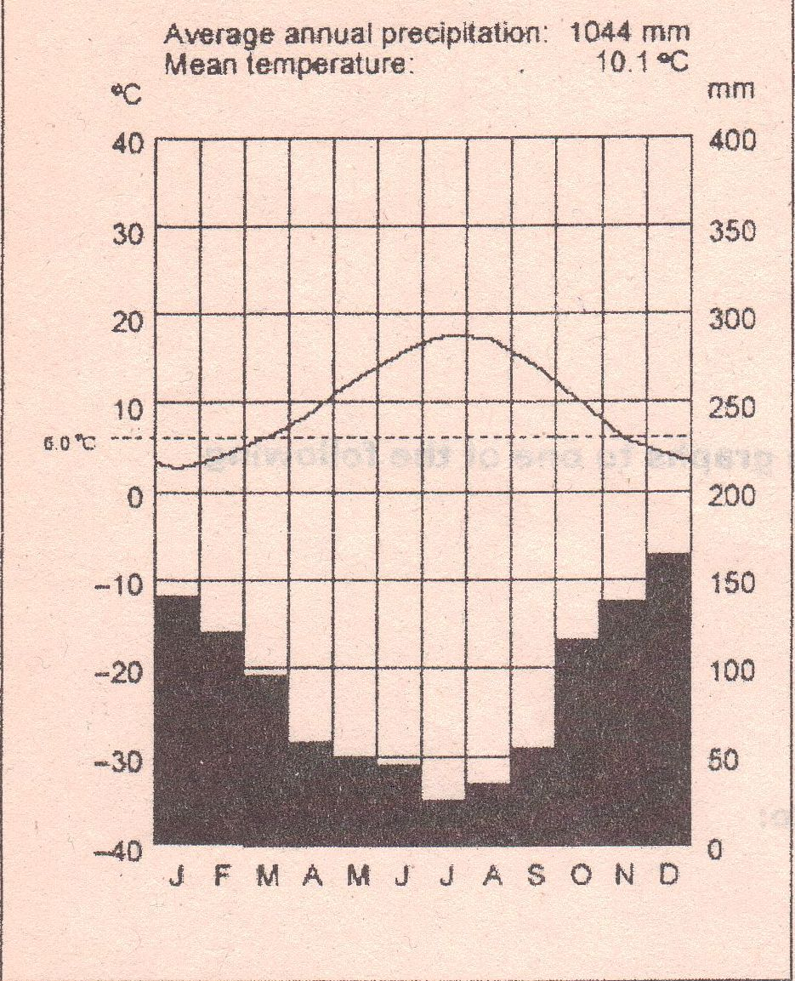

- The highest temperature recorded for the year is:

a. 18 degrees Celsius
b. -9 degrees Celsius
c. 160 degrees Fahrenheit
d. 2 degrees Celsius

- The climate of this region tends to have:

a. mild temperatures
b. less rainfall in the winter
c. hurricanes
d. all of the above

- The lowest rainfall recorded in the year happened in what month?:

a. April
b. May
c. June
d. July

Part C: Short Answer

1. Describe how a catastrophic earthquake could occur along the British Columbia coast.
____________________________________________________________________________________________________________________________________________________________________________________________________________________________________________________________________________________________________________________________________________________

4. Discuss problems faced by resource towns, but not large urban centres.
____________________________________________________________________________________________________________________________________________________________________________________________________________________________________________________________________________________________________________________________________________________

- What is the difference between a continental climate and a maritime climate? (2) __________________________________________________________________________________________________________________________________________________________________________________________________________________________________________

- Draw a diagram of frontal precipitation. Label the steps that are involved with this process. (5 marks)

Part D: Paragraph question.
Below are photographs and a climograph of an area in Alberta. How might an area such as this one affect what lives and grows in the region? (10) 

